

**University of Niagara Falls Canada**

**Master of Data Analytics**

**Assignment 2**

**Data Warehousing/Visualization (CPSC-510-5)****Winter 2025**

Professor: **Mehdi Mostofi**

Submitted By

Aarmi Patel (NF1002881)

Sarah Ikhagbode (NF1009120)

Mounika Ravella (NF1003648)

Mahvish Kounain (NF1014902)

Date: February 23, 2025

Table of Contents

**1.** **SALES PERFORMANCE FORECAST** 3

**A.** **Forecast Monthly and Yearly Sales Trends:** 3

**B.** **Predict Sales Performance by Regions:** 3

**C.** **Potential Peak Sales Period:** 3

**2.** **CUSTOMER ANALYSIS** 4

**A.** **Forecast demographic breakdown of customers (age, gender, location)** 4

**B.** **Segment customers based on predicted purchase behaviour** 6

**C.** **Analysis of Potential Customer Acquisition and Retention Rate** 6

**3.** **PRODUCT ANALYSIS** 7

**A.** **Forecast top-selling products and categories** 7

**B.** **Predict product return rates** 8

**C.** **Identify potentially underperforming products** 9

**4.** **PROFITABILITY ANALYSIS** 11

**A.** **Forecast gross profit margin by product and region** 11

**B.** **Predict cost analysis of goods sold** 11

**C.** **Forecast profit trends over time (Figure 4.C):** 12

**5.** **APPENDIX** 15

**6.** **REFERENCES** 26

# **SALES PERFORMANCE FORECAST**

## **Forecast Monthly and Yearly Sales Trends:**

From the analysis in **figure 1.A,** there are fluctuations in sales between the period January 2022 till September 2024. In the first half of the 2022 sales year the company experienced a steady increase from 7,821.12 to 8,731.67 although it peaked in May at 9561.25. From July till December sales fluctuated greatly, there was a significant fall between November and December with a difference of 2,554.44. Sales gradually started picking up slowly in January 2023 at 7683.61 and ended with a total of 8779.90 at December. January 2024 sales stood at 7614.49 and ends at 5422.93 in September making it the lowest among the years. Sales is forecasted to increase significantly in October 2024 to 7823.42 and remain steady up until September 2025.

## **Predict Sales Performance by Regions:**

From the analysis in **figure 1.B,** The West Was the Top Performer in 2022 but declined in 2023. It dropped below North (27,723.89), a 22.03% decline compared to 2022. The West region's dominance weakened, possibly due to shifting market conditions, competition, or economic factors. It should be investigated why West’s performance declined in 2023. North Became the best-performing region in 2023 & 2024 with sales at 27,723.89 and 20,417.03 indicating a strong customer base and demand. Therefore, marketing efforts in the North should be strengthened to sustain its growth. Despite North’s top position, the overall sales are declining year-over-year. West: 30,009.00 (2022) → Lower in 2023 → Even lower in 2024. North: 27,723.89 (2023) → 20,417.03 (2024) (Decline of ~26%).

**Recommendation:**

* Analyse market conditions to identify causes of the sales decline (e.g., competition, economic factors, product-market fit).
* Improve customer engagement strategies, enhance promotions, and introduce incentives to drive up sales.

## **Potential Peak Sales Period:**

From the analysis in **figure 1.C,** Peak sales periods were observed in specific months such as April, May, June, November, and December. For the month of April for the period 2022-2024 the company experienced its peak in total sales as 7,591.53, 7,272.74, and 8,835.15 respectively. The forecasted sales for the period 2025-2027 as shown in **figure 1.C.1**are 9213.19, 9761.13 and 10,308.35. Positive growth trend indicates strong market demand in April. The company should increase marketing campaigns and promotional offers to further boost sales

For the month of **May** (**figure 1.C.2)** the company’s peak in sales were 9,561.25, 7,564.10 and 7,516 for the 2022-2024 sales year respectively. The forecasted sales for the 2025-2027 sales year are 6,241.61, 5,141.73, and 4,041.84. From this analysis it is evident that sales are projected to have a steady decline over the years in contrast to the previous month. The declining customer demand maybe due to possible seasonal shift or external factors. Investigate reasons for the drop (e.g., competition, pricing, economic conditions) and introduce May-specific discounts or new product launches to boost sales.

**June** (**figure 1.C.3)** has its highest peak of 8731.67 in the year 2022 and then gradually declines to 8,145.78 and 6,798.00 in 2023 and 2024 respectively. The forecast shows sales will witness a decline by 14.65 % in 2025, a further decrease by 18.77 % and finally 23.1% in year 2026 and 2027 respectively. Demand shows a steady decrease possibly caused by shifts in consumer spending or seasonal change. Price adjustments or bundle promotions ought to be considered to attract buyers.

The month of **November** (**figure 1.C.4)** has its peak at 9,587.29 for the year 2022 and 8,284.48 for 2023. Similar to June the analysis forecast sales to drop significantly to 6,981.67, 5,678.86 and 4,376.05 implying a total of 89.3% decrease in sales. This infers a sharp drop in sales and suggests changing consumer behaviour in November. Introduce early holiday promotions (e.g., Black Friday, Cyber Monday sales) and improve marketing strategies (e.g., holiday-specific campaigns).

**December** (**figure 1.C.5)** peaks at 8779.90 for 2023 and 7032.85 for 2022. In comparison to the previous months the forecast projects a substantial increase in sales from 2024 to 2026. Sales is expected to increase in December 2024 to 10,526.95, 12,274.00, and 14,021.05 in 2025 and 2026. This signifies a huge 59.6% increase making December a key sales driver, likely due to holiday shopping trends. Ensure a strong supply chain to avoid stockouts during peak demand

**Overall Strategy**

* Focus on Growth Months (April, December) → Invest in marketing and inventory.
* Counter Declining Months (May, June, November) → Adjust pricing, promotions, and product strategies.
* Monitor Competitive Landscape → Analyze why sales are dropping in some months.

# **CUSTOMER ANALYSIS**

## **Forecast demographic breakdown of customers (age, gender, location)**

1. **Insights from Forecasted Customer demographic breakdown of customer by Gender**

From **figure 2.A.1,**we can summarise the customer demography below:

Balanced Gender Representation: The number of males and females is fairly balanced across most age groups. Females slightly outnumber males in certain bins (e.g., 40-50 years). The company should ensure marketing efforts appeal to both genders, but consider targeted campaigns for age groups where one gender is more dominant.

Increasing Trend in Customer Count with Age:Younger age groups (10-20 years) have fewer customers. The number of customers increases with age, peaking around 40-50 years.Target the older demographic (40-60 years) with personalized offers. If aiming for younger customers, enhance digital engagement strategies (social media, promotions, or influencer marketing).

Potential Drop in Young Customer Engagement: The 10-20 age group has the lowest representation in both male and female categories. Investigate why younger customers are underrepresented and consider youth-focused marketing strategies (loyalty programs, discounts, or mobile-based promotions).

1. **Insights from Forecasted Customer demographic breakdown of customers by Age Groups**

From **figure 2.A.2,**Younger Age Groups (10-20) Have Fewer Customers, the lowest count is seen in the youngest age group (10-20 years). A sharp increase from 24 to 91 customers is observed between 10-20 and 20-30 age groups. Focus on strategies to engage younger customers, such as social media marketing and student discounts.

Customer Base Peaks in the 30-40 and 40-50 Age Groups: 98 customers in both 30-40 and 40-50 age groups, indicating a stable middle-aged customer base. The count drops slightly to 92 customers in the 50-60 group but remains stable.The black trend line suggests steady growth in the overall customer base over time.

**Recommendation:**

* Maintain strong engagement with loyal customers in these age groups through targeted promotions and personalized offers.
* Develop campaigns that retain older customers by focusing on loyalty programs and customer experience improvements.

Uncertainty Beyond Age 60 (Wider Forecast Range)

The shaded area shows a higher variance in future forecasts for customers above 60 years. The forecast suggests potential growth but also uncertainty regarding customer engagement at older ages. Conduct further market research on older customers' preferences to better predict and engage this segment.

1. **Insights from Forecasted Customer demographic breakdown of customer by Location (figure 2.A.3)**

The North region has the highest customer count and sales, indicating strong engagement and sales performance. The East region has the lowest customer count and a declining trend, which suggests weaker customer engagement and lower sales. The scatter plot shows how customers are spread based on their Total Sales and Customer ID count. There is a wide distribution of customers, but a dotted trend line indicates a general pattern of customer distribution. North has the highest sales (72,253.23). East has the lowest sales (56,058.95). South and West are in between, with South at 63,591.7 and West at 67,484.21.

**Insights:**

The North region is performing well, and efforts should be made to maintain its growth. The East region needs attention perhaps through marketing, customer engagement, or promotions to boost sales and customer retention. Overall, sales are distributed across regions, but the gap between the highest and lowest-performing regions suggests room for improvement in underperforming areas.

## **Segment customers based on predicted purchase behaviour**

The purchase behaviour of customers was categorized into 4 **(Figure 2.B)** which will explained below:

1. **Risk Customers (41%):** These arethe largest segment, meaning a significant portion of customers are at risk of churning indicating potential dissatisfaction or lack of engagement. Retention strategies should be implemented such as personalized offers, re-engagement emails, and customer service follow-ups.
2. **Potential Loyalists (33%):** These are a considerable portion of customers who have shown promise but have not yet fully committed to the brand. These customers need nurturing to convert into loyal customers. Offer loyalty programs, incentives, or exclusive promotions to convert them into repeat buyers.
3. **Loyal Customers (21.4%):** A strong customer base that regularly engages and purchases. Strengthen brand advocacy by offering referral programs and exclusive perks. Provide personalized recommendations and early access to new products.
4. **Best Customers (4.6%):** This is a very small but highly valuable segment. These customers should be rewarded and used for referrals and testimonials. Recognize and reward them with VIP programs, special discounts, or exclusive experiences.

Utilize them for brand testimonials and case studies to attract more customers.

## **Analysis of Potential Customer Acquisition and Retention Rate**

1. **New Customer Acquisition Trend:** The number of new customers is declining from 2022 to 2024. The trend indicates a steady decrease, which could be a sign of market saturation, increased competition, or ineffective acquisition strategies.
2. **Customer Retention Rate Over Time:** The retention rate has been increasing from 2022 to 2024. This suggests improvements in customer satisfaction, loyalty programs, or better service offerings.
3. **Customer Churn Rate Trend:** The churn rate is gradually decreasing over time. A lower churn rate indicates that customers are staying longer, which aligns with the rising retention rate
4. **Net Customer Growth Over Time:** The overall net customer growth is increasing, with retention rates moving from 0.26 in 2022 to 0.79 in 2024.

This suggests that although new customer acquisition is declining, better retention is driving net growth **(figure 2.C)**.

**Recommendations:**

* **Enhance Retention Strategies:** Continue improving customer experience through personalized services and loyalty programs.Engage customers with consistent follow-ups, newsletters, or exclusive offers.
* **Boost Customer Acquisition Efforts:** Revamp marketing strategies to attract more new customers (e.g., targeted digital marketing, referral programs).Identify new customer segments or untapped markets.
* **Reduce Churn Further:** Identify reasons for past churn and address them with proactive customer support.Strengthen engagement through educational content, community building, and rewards.
* **Leverage Net Growth Trends:** Given the positive net customer growth, focus on nurturing long-term customer relationships. Consider expanding premium offerings or upsell/cross-sell strategies.Ensure operational capacity scales effectively to support growing customer retention.

# **PRODUCT ANALYSIS**

## **Forecast top-selling products and categories**

1. **Forecast top selling products based on quantity (figure 3.A.1)**

* **Key Findings & Trends:** Product 6 has shown a significant decline in total quantity, dropping from 52 in 2022 to 21 in 2023, followed by a slight recovery to 26 in 2024. However, the forecast predicts a continuous downward trend until 2027, with an increasing confidence interval, signalling uncertainty. The projected negative values in later years suggest potential issues with the forecasting model or significant market challenges.
* **Patterns & Anomalies:** The sharp drop from 2022 to 2023 indicates a possible market disruption, such as reduced demand, increased competition, or external economic factors. The brief recovery in 2024 does not sustain, reinforcing concerns of an ongoing decline. The forecast model's negative projections highlight the need for refining predictive methods to improve accuracy.

**Recommendations:**

* **Analyse Market Dynamics** – Identify key reasons behind declining sales by reviewing consumer preferences, competitor actions, and external economic factors.
* **Refine Forecasting Models** – Address potential flaws in prediction techniques to eliminate unrealistic negative values and improve accuracy.
* **Revitalize Sales Strategies** – Implement targeted marketing campaigns, competitive pricing, and bundling strategies to drive demand.
* **Expand Distribution Channels** – Diversify sales through e-commerce, direct-to-consumer approaches, and new geographic markets.

1. **Forecast top selling products based on sales (figure 3.A.2):**

* **Key Findings & Trends:** Total sales have shown a consistent decline, dropping from $97K in 2022 to $94K in 2023, followed by a sharper decline to $68K in 2024. The forecast predicts a continued downward trend through 2027, with an increasing confidence interval indicating greater uncertainty. The projected values suggest potential challenges in sustaining revenue growth, requiring strategic intervention.
* **Patterns & Anomalies:** The initial slight decline from 2022 to 2023 suggests minor market fluctuations, but the steeper drop from 2023 to 2024 signals a more significant disruption, possibly due to reduced consumer demand, market saturation, or economic downturns. The negative forecast values highlight potential issues with prediction accuracy, requiring model adjustments.

**Recommendations:**

* **Assess Market Trends** – Investigate shifts in customer preferences, competitor pricing strategies, and economic factors affecting sales.
* **Refine Forecasting Techniques** – Improve model accuracy by incorporating external economic indicators and adjusting for anomalies.
* **Enhance Sales Strategies** – Implement targeted promotions, customer engagement campaigns, and pricing optimizations to stabilize revenue.
* **Diversify Revenue Streams** – Explore alternative sales channels, product innovations, and new market segments to counter declining trends.

1. **Forecasting top selling category (Figure 3.A.3)**

* **Key Findings & Trends:** The Books category has exhibited a declining sales trend, dropping from 23.4K units in 2022 to 21.2K in 2023 and further down to 17.7K in 2024. The forecast suggests a continuous downward trajectory through 2027, with an expanding confidence interval, highlighting potential uncertainty in future projections. If this trend persists, sales could reach critically low levels, impacting overall revenue in this category.
* **Patterns & Anomalies:** While the initial decline appears gradual, the steeper projected drop after 2024 suggests possible market shifts, changing consumer behaviour, or reduced demand for books. The widening prediction interval indicates increased variability, meaning external factors such as economic conditions or digital alternatives (e-books, audiobooks) may significantly influence outcomes.

**Recommendations:**

* **Adapt to Market Changes** – Explore digital formats, subscription models, or strategic partnerships to counter declining demand.
* **Strengthen Marketing Efforts** – Leverage targeted promotions, social media campaigns, and influencer collaborations to boost engagement and sales.
* **Diversify Product Offerings** – Introduce bundled deals, collector’s editions, or exclusive content to retain customer interest.
* **Inventory Optimization** – Adjust supply chain operations to prevent overstocking and reduce inventory costs, ensuring profitability despite declining demand.

## **Predict product return rates**

* **Key Findings:** The bar chart (**Figure 3.B)** illustrates the predicted return rates of various products, highlighting high-risk products using a colour gradient from yellow (low risk) to red (high risk). Products with higher predicted return rates indicate a greater likelihood of being returned by customers, which could be due to multiple factors such as pricing, quality issues, misleading descriptions, or market trends. The top two products—Product 5 (1.00 predicted return rate) and Product 2 (0.79 predicted return rate)—stand out as the highest-risk products. These products are marked in deep red, indicating a very high return probability. Other products, like Product 39 (0.46), Product 75 (0.39), and Product 81 (0.30), also show moderate return risks but are comparatively lower than the top two.
* **Observed Trends and Patterns**

1. **High Return Rate Products:** The highest return rates belong to a small number of products, which suggests that certain items may have specific issues causing high return rates.
2. **Gradual Decline in Return Risk:** The return rates gradually decline as we move down the list, with the lowest return rates (around 0.13) seen in Product 43 and Product 46.
3. **Category-Based Filtering Option:** The presence of category filters (Books, Clothing, Electronics, Home) indicates that return trends could differ based on product types. If applied, these filters may reveal that certain categories have more return-prone products than others.
4. **Anomalies:** Products like Product 5 and Product 2 have unusually high return rates compared to others, suggesting possible issues like misleading descriptions, poor quality, or higher expectations set by customers.

**Recommendations:**

* **Investigate High-Risk Products:** The company should conduct a deeper analysis of Product 5 and Product 2, as their predicted return rates are significantly higher than others. Possible reasons could include quality concerns, misleading product images, or incorrect descriptions.
* **Improve Product Descriptions:** If certain products have high return rates, their descriptions, specifications, and images should be reviewed for accuracy to reduce customer dissatisfaction.
* **Quality Control for High-Risk Items:** Products with a predicted return rate above 0.30 should undergo a quality check to identify and address potential issues.
* **Category-Specific Analysis:** Applying the category filter could reveal whether a specific product type (e.g., clothing or electronics) has higher return rates. This would help in forming targeted strategies.
* **Pricing Adjustments:** If returns are related to pricing concerns, introducing discounts, better pricing strategies, or clearer value propositions may help in reducing return rates.

## **Identify potentially underperforming products**

* **Key Findings:** The bar chart presents a comparison between underperforming and well-performing products based on their total sales amounts. The dataset can be filtered by year (2022, 2023, and 2024) and performance breakdown. The current view displays only the well-performing products, highlighted in purple.

From the chart (**Figure 3.C)**, Product 85 (1,840 sales amount) stands out as the highest-selling item, followed by Product 63 (1,462), Product 50 (1,444), and Product 9 (1,352). These top products contribute significantly to revenue. The sales amounts gradually decline across the chart, with the lowest-performing well-performing product, Product 97, recording 499 sales amounts.

* **Observed Trends and Patterns**

1. **Significant Variation in Sales Performance:** The highest-selling product (Product 85) has nearly four times the sales of the lowest well-performing product (Product 97). This suggests that a few top products drive most of the revenue.
2. **Gradual Decline in Sales:** The sales figures decrease steadily rather than dropping abruptly, which means there is a balanced distribution of well-performing products.
3. **Potential for Further Analysis:** The presence of a filter for underperforming products indicates that certain products might be struggling in terms of sales. Comparing both categories can provide deeper insights into inventory and marketing strategies.
4. **Yearly Trends Impacting Sales:** The ability to filter by year suggests that analysing trends over time (2022, 2023, and 2024) could help identify whether specific products have consistently performed well or if there are fluctuations due to market conditions, pricing changes, or customer preferences.

**Recommendations:**

* **Leverage Best-Selling Products:** The top-performing products (e.g., Product 85, Product 63) should be prioritized for promotions, bundled offers, and stock availability to maximize sales.
* **Investigate Underperforming Products:** A comparative analysis with the underperforming category is needed to identify common factors affecting low sales—such as pricing issues, lack of customer interest, or weak marketing.
* **Monitor Yearly Trends:** If certain products show declining sales across years, strategies like rebranding, discount offers, or seasonal promotions could help maintain performance.
* **Inventory Optimization:** Understanding which products consistently perform well helps in optimizing stock levels, ensuring that high-demand items are always available while reducing excess inventory for underperforming products.
* **Targeted Marketing Campaigns:** The best-selling products can be used for targeted advertisements, and strategies should be developed to boost mid-tier performing products to enhance overall revenue.

# **PROFITABILITY ANALYSIS**

## **Forecast gross profit margin by product and region**

* **Key Findings:** The line chart **(Figure 4.A)** displays the Gross Profit Margin (GPM) trend over the years 2022 to 2024, along with a forecast for the upcoming years. The GPM values are negative, indicating losses. The table on the right lists individual products and their respective gross profit margins, with Product 11 (-4.24) and Product 17 (-3.67) showing the highest losses. The total GPM across all products is -2.04, signalling a significant profitability issue.

From the trend:

* In **2022**, the GPM was -2.004.
* It further declined in **2023** to -2.114, indicating worsening profitability.
* In **2024**, the GPM slightly improved to -1.990, suggesting a potential recovery.
* The forecast (shaded area) for the coming years shows an uncertain trend, but with a possibility of stabilization if corrective actions are taken.
* **Observed Trends and Patterns**

1. **Overall Negative GPM:** The business is operating at a loss, requiring urgent strategic actions to improve profitability.
2. **Slight Recovery in 2024:** The upward movement in 2024 suggests that interventions (pricing adjustments, cost reductions) may be helping, but more efforts are needed.
3. **Product-Level Losses:** Several products have highly negative margins, with Product 11 and Product 17 being the worst. These products need detailed analysis to understand cost structures and pricing strategies.
4. **Forecasted Uncertainty:** The shaded area in the forecast indicates variability in potential outcomes, meaning the business must take proactive steps to avoid further financial decline.

**Recommendations:**

* **Reevaluate Pricing Strategies:** Certain products may be priced too low relative to their costs. Competitive pricing analysis and dynamic pricing strategies should be explored.
* **Cost Reduction Measures:** Identify key cost drivers and explore options such as bulk purchasing, supplier negotiations, or operational efficiency improvements.
* **Eliminate or Revamp Unprofitable Products:** Products like Product 11 and Product 17 should either be optimized (through better sourcing or pricing adjustments) or discontinued if they remain highly unprofitable.
* **Increase High-Margin Offerings:** If any products have positive or less negative margins, focus on their promotion and expansion to balance overall profitability.
* **Monitor and Adjust Regularly:** Given the fluctuations in GPM, businesses should conduct frequent profitability analyses and adapt strategies based on real-time data.

## **Predict cost analysis of goods sold**

* **Key Findings and Insights (Figure 4.B)**:
* **Fluctuating Monthly COGS**: The monthly COGS data reveals significant variations, with peaks and troughs occurring irregularly. This implies variability in the cost of goods sold, possibly due to seasonal factors, market conditions, or changes in production costs.
* **Overall Decline in Annual COGS**: The annual COGS data displays a downward trend from 2022 to 2027. This indicates potential optimization in cost management strategies over time, leading to decreased costs.
* **Forecast Confidence**: The shaded area in the annual COGS graph denotes the confidence interval, indicating the expected range within which the actual COGS may fall. The widening of the shaded region over time suggests increasing uncertainty in the forecast as we move further into the future.
* **Observed Trends and Patterns:** Certainly, here are the trends, patterns, and anomalies observed in the forecasted data:
* **Fluctuating Monthly COGS**: Monthly COGS shows significant fluctuations, with irregular peaks and troughs, indicating variability due to seasonal factors, market conditions, or changes in production costs.
* **Decline in Annual COGS**: The data indicates a general downward trend in annual COGS from 2022 to 2027, suggesting potential optimization in cost management strategies over time.
* **Forecast Confidence**: The widening confidence interval in the annual COGS graph implies increasing uncertainty in the forecast as we move further into the future.

**Recommendations:**

* **Cost Management Strategies**: Businesses should focus on identifying the factors contributing to the fluctuations in monthly COGS and implement strategies to stabilize these costs. This could include negotiating better supplier contracts, optimizing inventory management, and improving production efficiency.
* **Long-term Planning**: Given the forecasted decline in annual COGS, businesses should plan for long-term cost reductions. This could involve investing in technology and automation to reduce labour costs, exploring alternative raw materials, and improving supply chain management.
* **Monitoring and Adjustments**: Regularly monitor COGS data to identify any deviations from the forecasted trends. Businesses should be prepared to adjust their strategies in response to changing market conditions and other external factors.

## **Forecast profit trends over time (Figure 4.C):**

* **Key Findings**
  + **Monthly COGS Trends (2022-2024)**: The monthly COGS data displays notable fluctuations, with significant peaks and troughs. In early 2022, the COGS begins at 25.1K in January, reaches a peak of 26.0K in February, and declines to 20.2K by May. This pattern continues, with a rise to 27.2K in July 2022, followed by a drop to 23.5K in October 2022, and peaking again at 30.7K in January 2023. The fluctuations persist through mid-2023 to early 2024, with notable values such as 27.7K in June 2023 and 28.3K in January 2024, and a dip to 19.5K in March 2024. The COGS eventually trends downward, ending at 19.0K in July 2024.
  + **Annual COGS Trends (2022-2027)**: The annual COGS data indicates a relatively stable trend at 0.29M from 2022 to 2023, followed by a noticeable decline to 0.20M in 2024. The forecast suggests a continued downward trend from 2025 to 2027, with the COGS projected to decrease further, reaching approximately 0.1M by 2027. The forecasted data shows a widening confidence interval, indicating increasing uncertainty over time.
    - **Detailed Explanations**
      * **Fluctuating Monthly COGS**: The data reveals significant monthly fluctuations, with irregular peaks and troughs indicating variability due to factors such as seasonality, market conditions, or changes in production costs. These variations suggest the need for businesses to closely monitor and manage these fluctuations to maintain profitability.
      * **Overall Decline in Annual COGS**: The downward trend in annual COGS suggests that businesses may be optimizing their cost management strategies, leading to reduced costs over time. This trend indicates a positive outlook for businesses focusing on long-term cost reduction and efficiency improvements.
      * **Forecast Confidence**: The shaded area in the annual COGS graph represents the confidence interval, showing the range within which the actual COGS is expected to fall. The widening confidence interval over time suggests increasing uncertainty in the forecast, emphasizing the need for businesses to remain agile and adapt to changing conditions.
  + **Observed Trends and Patterns:**

The forecasted data reveals significant trends and patterns in the COGS from 2022 to 2027. The monthly COGS shows substantial fluctuations, with peaks and troughs occurring irregularly, hinting at variability due to seasonal factors, market conditions, or changes in production costs. The data indicates a general downward trend in annual COGS, suggesting potential optimization in cost management strategies over time. However, there is increasing uncertainty in the forecast as depicted by the widening confidence interval in the annual COGS graph. Understanding these fluctuations and downward trends can help businesses better manage costs and improve financial performance.

**Recommendations:**

* **Cost Management Strategies**: Businesses should focus on identifying factors contributing to the fluctuations in monthly COGS and implement strategies to stabilize these costs. This could include negotiating better supplier contracts, optimizing inventory management, and improving production efficiency.
* **Long-term Planning**: Given the forecasted decline in annual COGS, businesses should plan for long-term cost reductions. This could involve investing in technology and automation to reduce labor costs, exploring alternative raw materials, and improving supply chain management.
* **Monitoring and Adjustments**: Regularly monitor COGS data to identify any deviations from the forecasted trends. Businesses should be prepared to adjust their strategies in response to changing market conditions and other external factors.

# **APPENDIX**

**Figure 1.A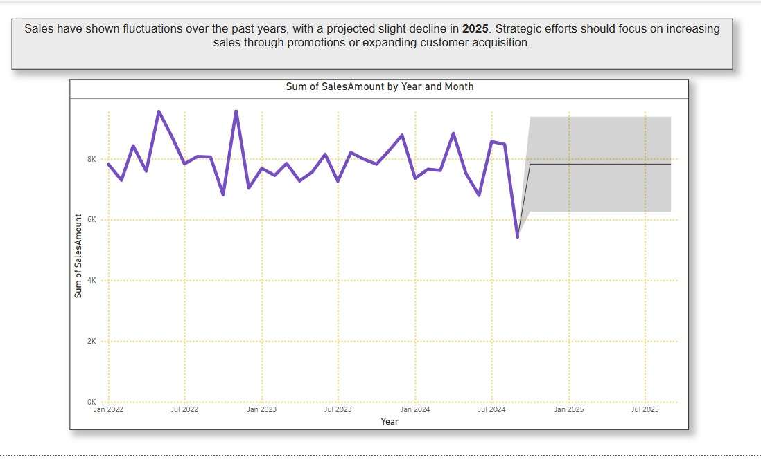Figure 1.B**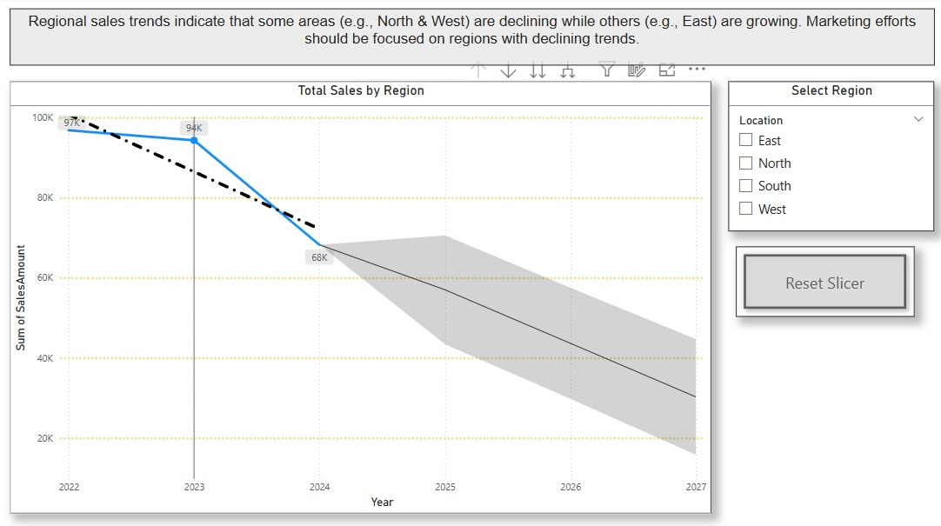

**Figure 1.C**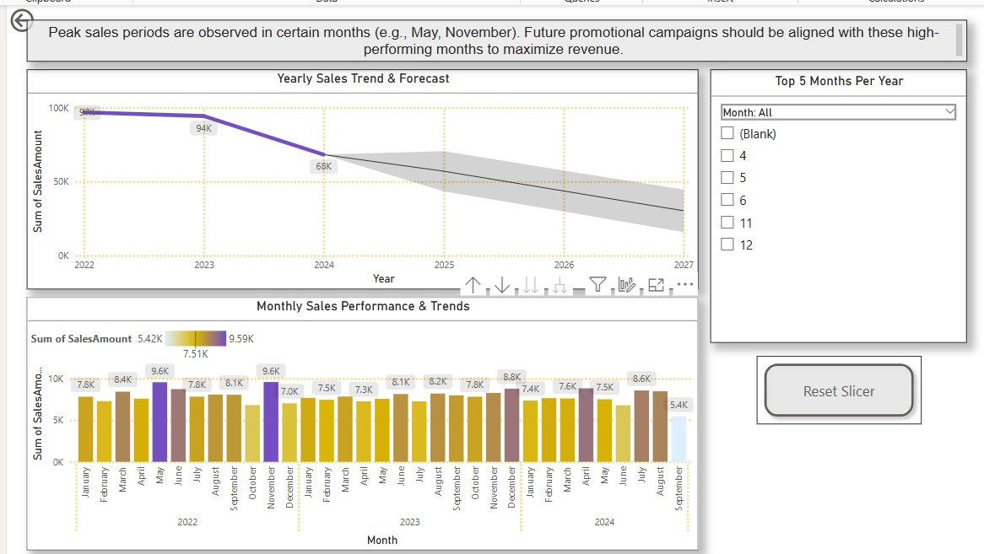

**Figure 1.C.1**

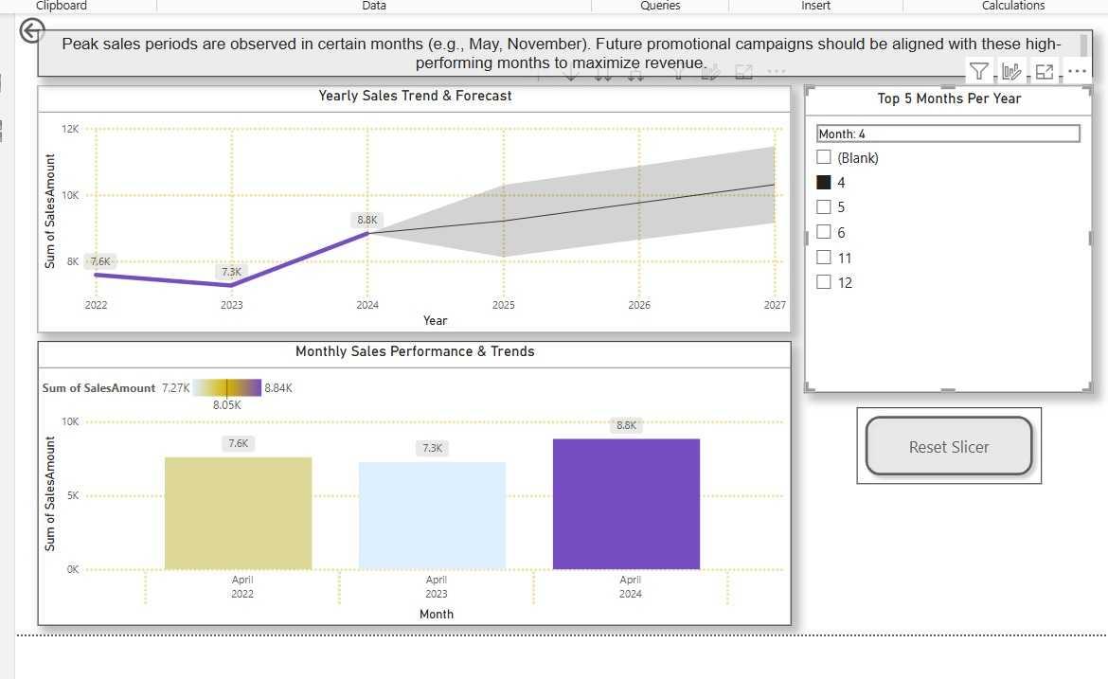

**Figure 1.C.2**

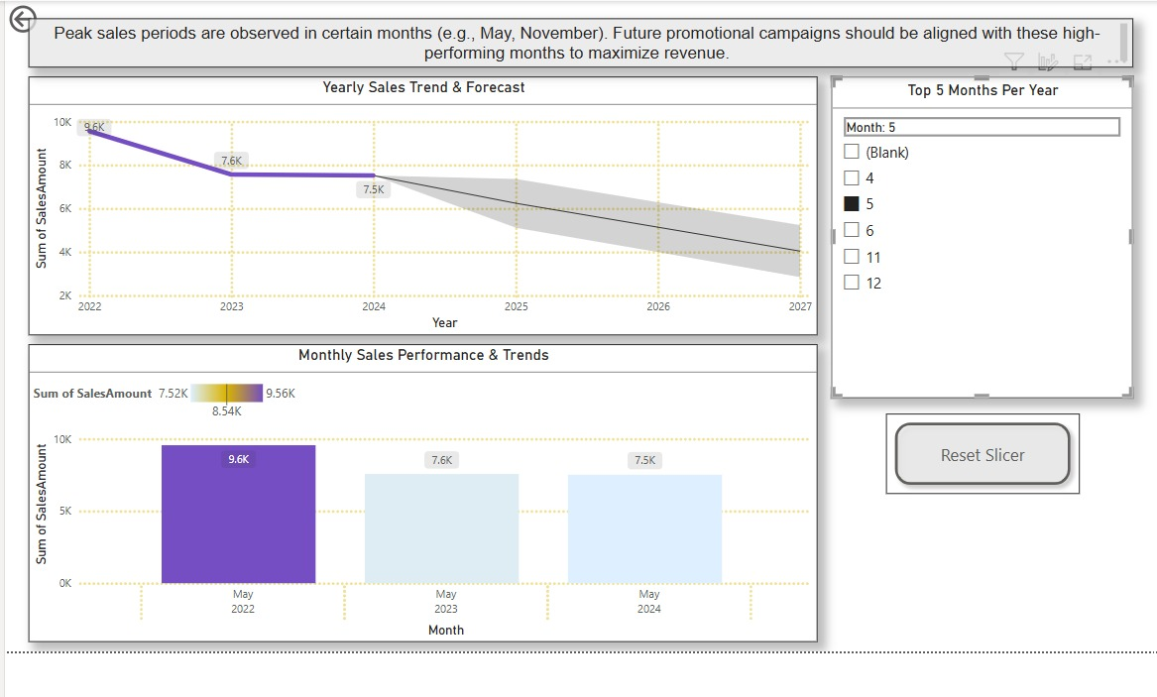

**Figure 1.C.3**

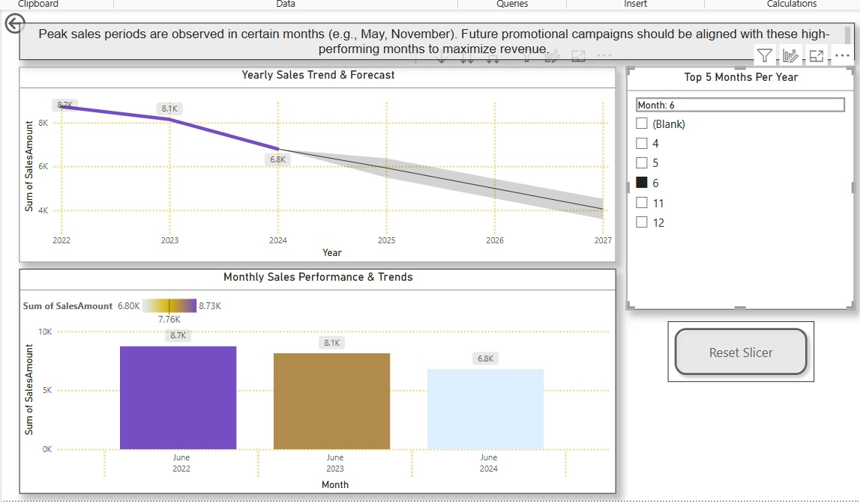

**Figure 1.C.4**

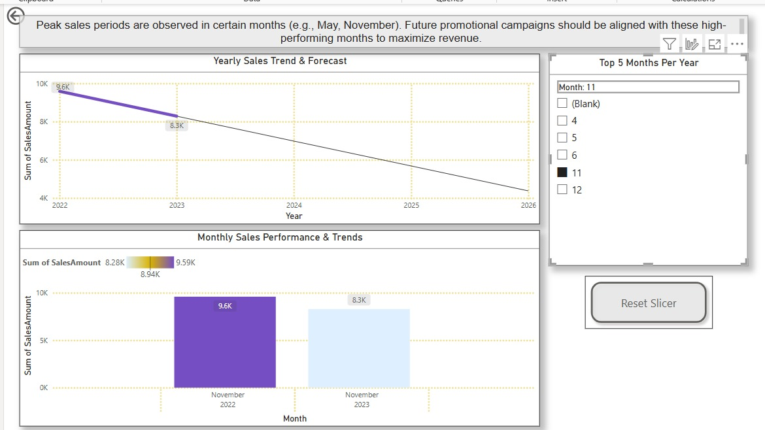

**Figure 1.C.5**

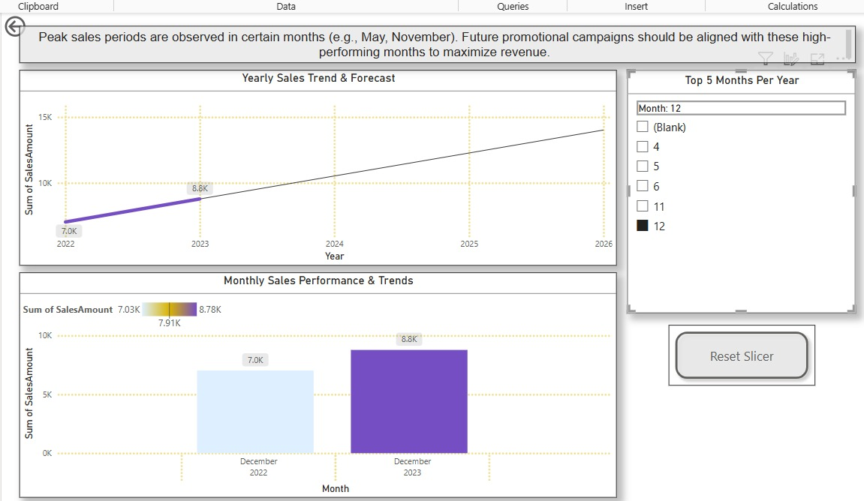

**Figure 2.A.1**

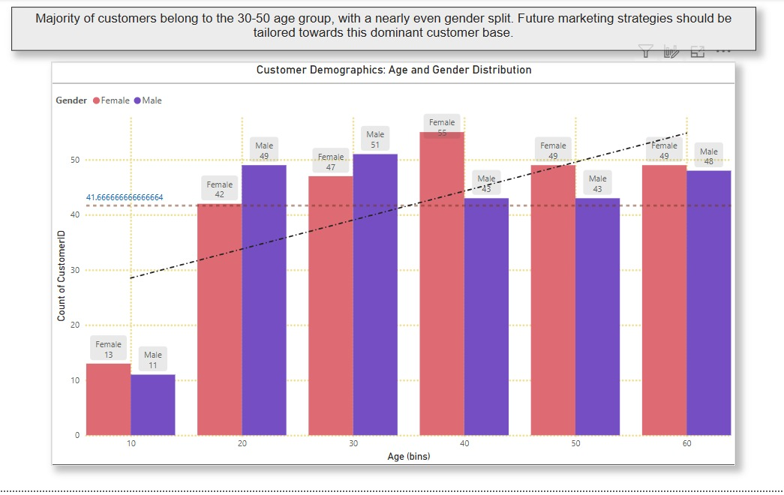

**Figure 2.A.2**

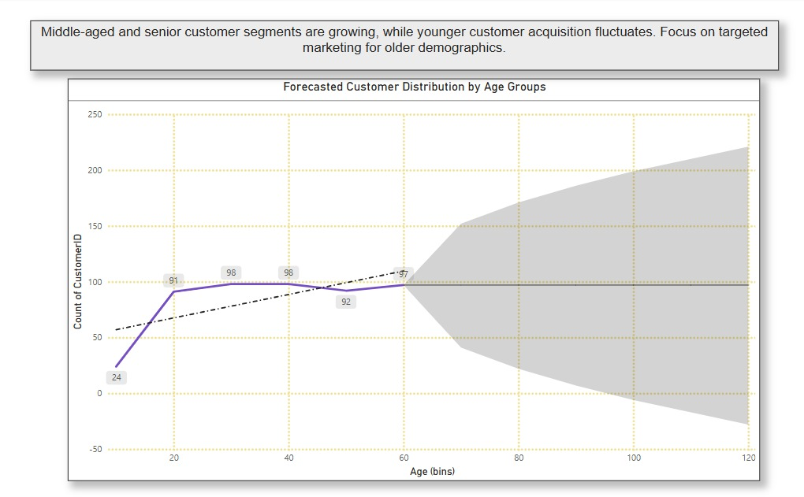

**Figure 2.A.3**

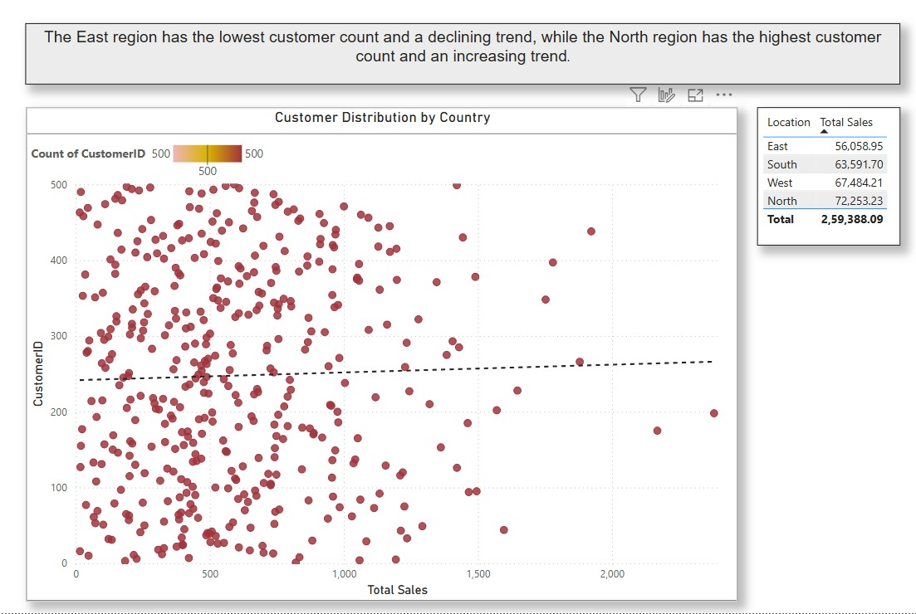

**Figure 2.B**

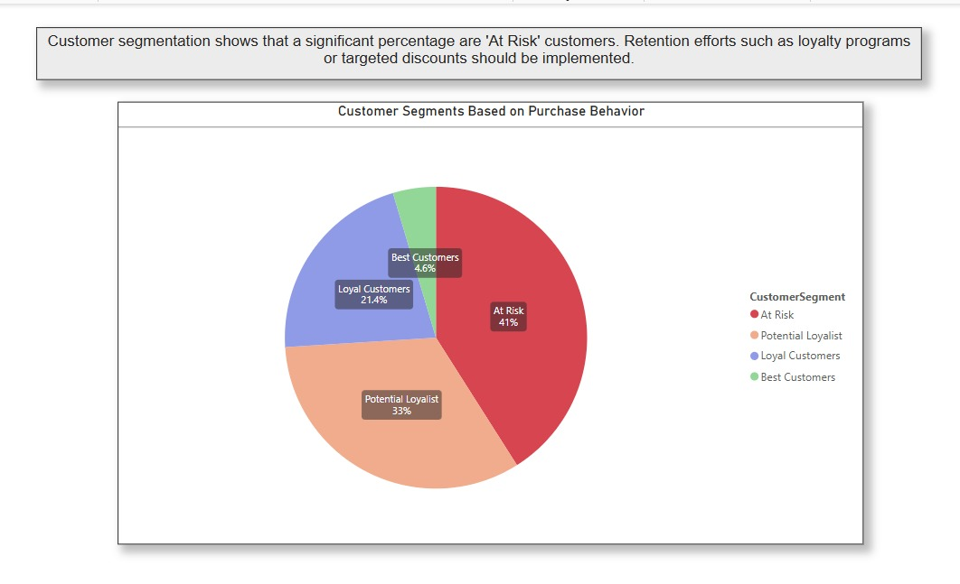

**Figure 2.C**

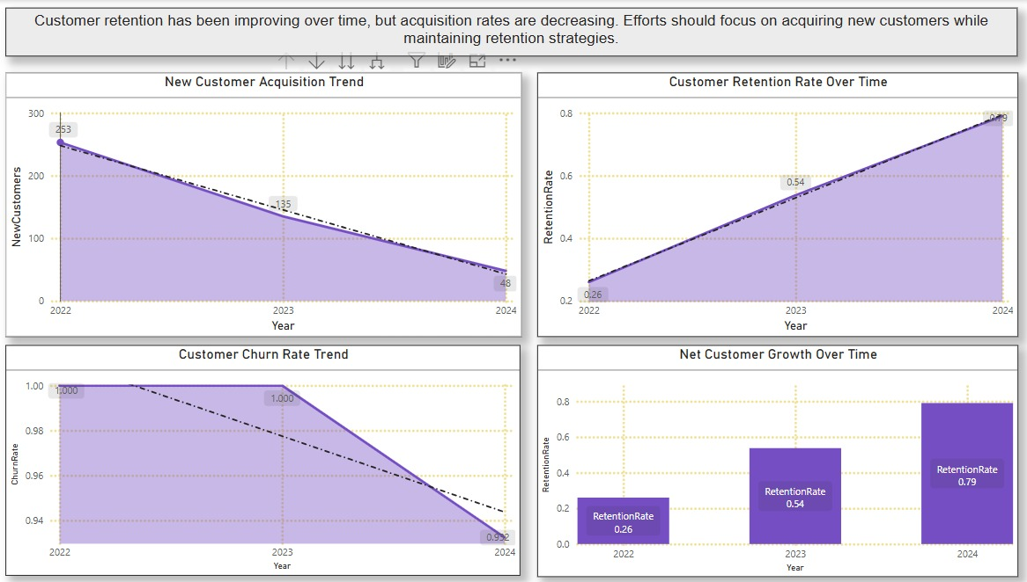

**Figure 3.A.1**

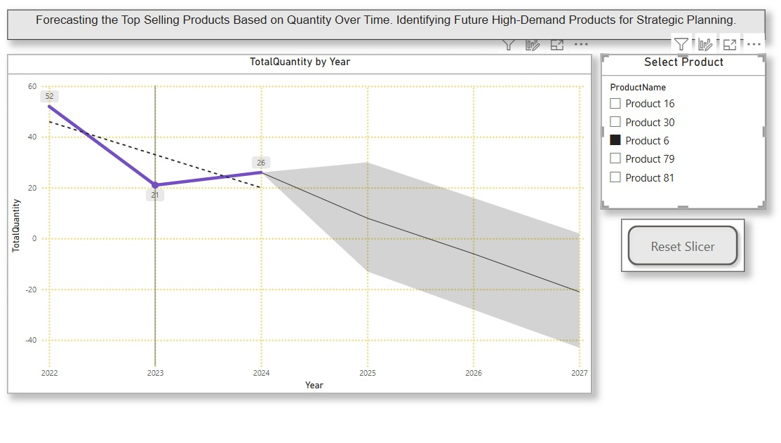

**Figure 3.A.2**

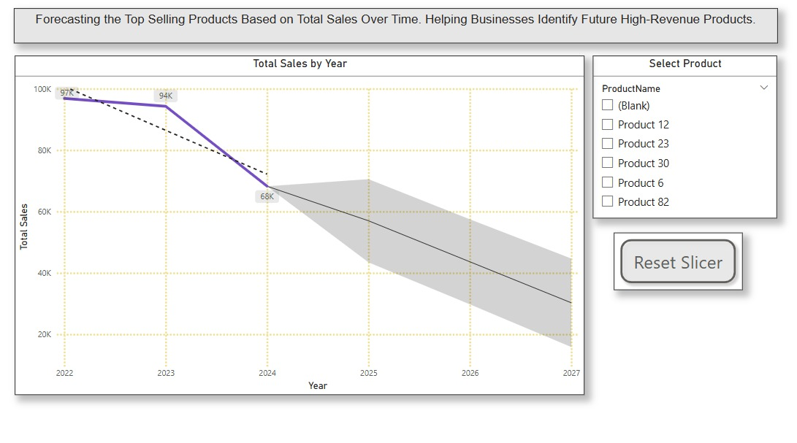

**Figure 3.A.3**

**Figure 3.BA screenshot of a computer

AI-generated content may be incorrect.**

**Figure 3.CA screenshot of a graph

AI-generated content may be incorrect.**

**Figure 4.AA graph on a white background

AI-generated content may be incorrect.**

**Figure 4.BA screenshot of a graph

AI-generated content may be incorrect.**

**Figure 4.C A graph with purple lines

AI-generated content may be incorrect.**

# **REFERENCES**

1. Books:
   * Marco Russo & Alberto Ferrari – The Definitive Guide to DAX: Business Intelligence for Microsoft Power BI, SQL Server Analysis Services, and Excel (Microsoft Press, 2019)
   * Adam Aspin – Pro Power BI Desktop (Apress, 2017)
   * Reza Rad – Power BI DAX Simplified: DAX and Calculation Language of Power BI (RADACAD Systems Limited, 2021)
2. Microsoft Documentation

* Microsoft Learn **–** Power BI Documentation – <https://learn.microsoft.com/en-us/power-bi/>
* Microsoft Learn **–** DAX Functions Reference – <https://learn.microsoft.com/en-us/dax/>
* Microsoft Learn **–** Model Relationships in Power BI – <https://learn.microsoft.com/en-us/power-bi/transform-model/desktop-relationships-understand>

1. Online Articles and Blogs

* Enterprise DNA– Best Practices for Power BI Data Modelling – <https://blog.enterprisedna.co/power-bi-data-modeling-best-practices/>
* RADACAD **–** Optimizing Performance in Power BI – <https://radacad.com/power-bi-performance-optimization>
* SQLBI – DAX Guide – <https://www.sqlbi.com/dax-guide/>

1. Videos & Courses

* Guy in a Cube (YouTube Channel) **–** Power BI Tutorials & Performance Optimization – <https://www.youtube.com/c/GuyinaCube>
* Microsoft Learn **–** Data Modellinga in Power BI – <https://learn.microsoft.com/en-us/training/paths/model-data-power-bi/>